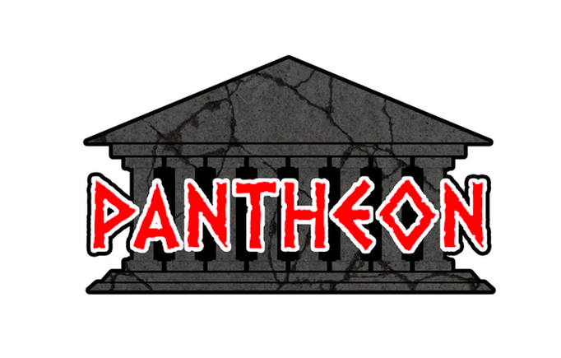
SALES & RENTALS IS HIRING!!!

Love what you do!!!
Want to turn your job into a career!!!

We are looking for an Inside Sales Rep!

Requirements Include:
- Concrete and/or coatings knowledge
- Full-Time work schedule availability
- Speaks Spanish & English

Includes:
Competitive Pay
Eligible for Overtime
Benefits

Ask Yesica for details or
Call Caprice at 303-710-2356

