

Instruction Manual

F Series Dust Extractors

Introduction

Dear customer:

Thanks for choosing Forte F series dust extractor!

Notice!

This instruction manual is only for the F18, F26 & F36 dust extractor.

The F Series dust extractor can only be used with dry, non-explosive material.

Forte will not be held responsible if the dust extractor is used for other
applications or beeing used in ways other than those explained in this instruction manual.

Before using the machine, please read the safety instructions carefully.

Read the complete instruction manual before using the F Series dust extractor.

All spare part used for the F Series dust extractor must be those specified by Forte Tools.

Table of Contents

1 | Safety Instructions | 6 | Filter Changing
2 | Unpacking | 7 | Service
3 | Function Principle | 8 | Trouble Shooting
4 | Filter Changing | 9 | Warranty
5 | Dust Collection System | 10 | Technical Data

- Safety Instructions

Application:

- The machine must not be used in environments where explosive gases may be present.
- Don’t use outdoors or on a wet surface, this machine is for indoor and dry application only.
- Dust extractors are not suitable to extract solid particles with sharp edges, which will cause damage to the hose, filters, drum and continuous dropping bags.

Electric safety:

- Before using the dust extractor, please check and make sure electrical cords are not exposed or damaged.
- Confirm that the voltage and current of your available power supply can support the machine.
- The dust extractor must be switched off and unplugged if the operator leaves for an extended period of time.

Personal Safety Protection:

- Keep children and pets away from the machine while the dust extractor is working.
- This dust extractor must be handled by an experienced operator, or by an adult with necessary training.
- Wear personal safety protection equipment like gloves, goggles, masks and earplug while using the dust extractor.
- DO NOT touch the plug, electrical wire or other electric components while dust extractor in running.

Maintenance:

- Before maintenance, make sure that the dust extractor is unplugged and powered off.
- Only let experienced and qualified workers change or fix any electrical components.
- Use proper hand tools or electrical tools while assembling or disassembling the dust extractor, to prevent damaging the nuts and bolts, and causing unnecessary bodily injury.

Storage:

- Dust extractors must be stored in a dry environment, indoors, and never put outdoors.
- Do necessary cleaning needed for the dust extractor before putting it in storage to prolong its life.

- Packaging List

Please check below listed accessories that comes with every single dust extractor.

F18  D38* 5mm hose with 2 cuffs  1* round brush  1* floor brush  1* crevice tool  1* S wand  1* 70/38 reducer | F26  D50* 7.5mm hose with 2 cuffs  1* floor brush  1* crevice tool  1* S wand  1* 70/50 reducer | F36  D50* 7.5mm hose with 2 cuffs  1* floor brush  1* crevice tool  1* S wand  1* 70/50 reducer

Please contact your local distributors or sales representatives if above mentioned accessories are not included in the package.

- Function Principle

The dust extractors are designed to pick up and extract dry, non-explosive and non-hazardous dust and particles.

It can achieve an ultimate filtration efficiency up to 99.99% @ 0.3um, as the dust extractors are designed with a 3-step filtration system.

1. The bigger dust or particles sucked up through the air inlet will drop down into the vacuum bag with gravity. More particles will also drop down by the centrifugal force.

2. The rest of the dust and particles will be blocked and cleaned out by the conical pre-filter with filtration up to 99.5% @1um.

3. Then the smallest dust or particles left will be filtered through the HEPA filter with filtration efficiency up to 99.99@ 0.3um.

- Filter Cleaning

The filters must be cleaned time to time to maintain excellent suction performance. If the vacuum gets hot or produces a high-pitched noise, it may mean the pre-filters are blocked with large amount of dust.

How do I clean the filters?
First, pull up the metal pull latch to seal the air inlet, the vacuum within the drum will soon build up. Then press the jet-pulse handle for 5 seconds, then repeat this procedure 4-5 times. We need to wait 5 second between every interval. Finally push down the metal plate for air intake again.

Please reference below picture for the cleaning procedure.

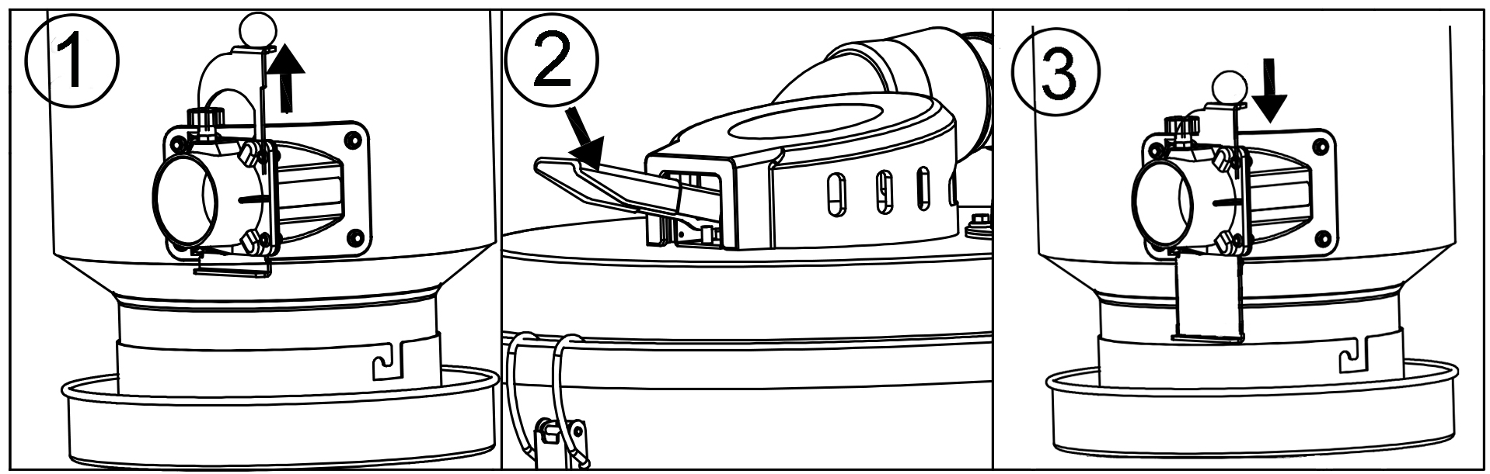

- Dust Collection System

The dust collection system contains a bag holder, nylon puller strap with metal buckle, nylon ties and continuous dropping bags with size of 357mm*20m*6.5decimillimeter.

Equipping the continuous bag: First, unlock the bag holder, put the continuous dropping bag into the holder, tie up the bottom of the bags with nylon ties, and fasten the nylon puller strap for sealing.

Getting rid of the dust: When the bag is full of dust or particles, tie up the top of the bag with 2 nylon ties, finally cut the bag between the 2 nylon ties to prevent the dust from being inhaled and/or exposed to the air.

Notice: Please remember to throw the bags into the dust bin or a designated area.

Please reference below pictures for above bag cleaning procedure.

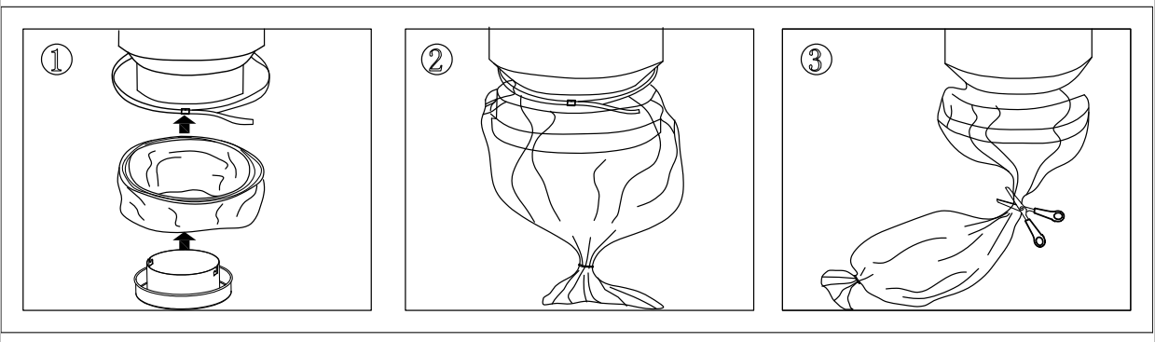

- Filter Change

Notice:

- The operator must wear mask, goggle and gloves while changing the filter to protect against any dust.
- Must use appropriate pre-filters and HEPA filters purchased from us or nearest distributor. Please do not use off brand filters not purchased through us. We can not warranty the machine if non designated filters were used.

Pre-filter:

- Prepare a clean and empty bag in which to put the filter.
- Loosen the 3 clamps, take off the main drum cover.
- Lift up the filter gently and put inside the bag, and seal the bag.
- Insert a new filter.

HPEA filter:

- Prepare a clean and empty bag in which to put the filter.
- Loosen 2 nuts, take out the filter cover.
- Lift up the filter gently and put inside the bag, and seal the bag.
- Insert a new filter.

- Service

- When cleaning or servicing the machine, you must switch off the machine and remove the plug.
- Avoid cleaning with a high pressure cleaner.
- Before moving the machine from the work area, the machine must first be cleaned.
- All other equipment must be regarded as contaminated and be treated thereafter.
- If possible, use a special desginated room just for servicing.
- Proper personnel protective equipment must be used.
- All parts which are contaminated after service must be carefully disposed of in plastic bags according to local regulations.
- If the machine has to be used for other purposes, it is extremely important that the machine is cleaned, to avoid the spread of hazardous dust.

- Trouble Shooting

The machine owner/operator must follow all the instructions within this user manual and carefully operate and maintain the dust extractor. All the parts need to be checked and replaced in a timely manner if broken. Please check all the parts are connected correctly.

Trouble | Causes | Solutions
Motor doesn’t start | No power | Plug in machine
Motor doesn’t start | Cable defective | Replace cable
Motor doesn’t start | Switch defective | Replace switch
Motor stops immediately after starting | Shortcut in cable/machine | Order service
Motor runs but there is not suction | Hose not connected | Connect hose
Motor runs but there is not suction | Hose clogged/ blocked | Clean hose
Motor runs but there is not suction | No dust collection bag | Fit dust collection system
Motor runs but poor suction | Hole in hose | Replace hose
Motor runs but poor suction | Filter clogged | Clean filter/ Replace filter
Motor runs but poor suction | Loose top cover | Adjust
Motor runs but poor suction | Defective gaskets | Replace affected gasket
Dust blown from motor | Wrong assembled or damaged filter system | Adjust/ Replace filter
Abnormal noise |  | Order service

- Warranty

All our devices and accessories have a 12-month factory warranty for material and manufacturing defects. Do not attempt to repair the dust extractor without the consent of the manufacturer.
The warranty does not cover defects which are the result of normal wear and tear, negligence, defective use, unauthorized repair or the dust extractor being connected to the incorrect voltage.
In the event of any complaint, the dust extractor or an agreed part of it must be returned to us or our authorized representative for warranty examination and for any warranty repair or replacement.

- Technical Data

Data | Unit | F18 120V | F26 120V | F36 120V | F36 240V
Voltage | V | 120 | 120 | 240 | 240
Power | W | 1700 | 2400 | 2400 | 3600
Power | HP | 2.3 | 3.2 | 3.2 | 4.8
Current | A | 15 | 18 | 18 | 50
Airflow (max) | m3/h | 300 | 400 | 485 | 600
Airflow (max) | cfm | 176 | 236 | 285 | 354
Vacuum (max) | mbar | 348 | 220 | 180 | 220
Vacuum (max) | Inch” | 140 | 100 | 72 | 100
Main hose | Metric | D38*5m | D50*7.5m | D50*7.5m
Main hose | USCS | 1.5”*16.4’ | 2”*24.6’ | 2”*24.6’
Inlet | Metric | 38mm | 50mm | 50mm
Inlet | USCS | 1.5” | 2” | 2”
Pre-filter | 99.5% @ 1um
Pre-filter area | Metric | 1.5m2 | 2.8m2 | 4.2m3
Pre-filter area | USCS | 16ft2 | 30ft2 | 45ft2
HEPA filter  EN1822-H13 | 99.99% @ 0.3um
Total HEPA filter area | Metric | 1.2m2 | 2.4m2 | 3.6m2
Total HEPA filter area | USCS | 13ft2 | 26ft2 | 39ft2
Sound level | dB(A) | 72 | 73 | 73
Dust Collection |  | Plastic bag
Dimension (L*W*H) | Metric | 426*691*1115mm | 544*698*1318mm | 544*820*1459mm
Dimension (L*W*H) | USCS | 16.8*27.2*44” | 21.4*27.5*52” | 21.4*32.3*57.4”
Net Weight | Metric  (kg) | 35 | 57 | 65
Net Weight | Lbs | 77 | 125 | 143

EXPLODED VIEW,
Forte F18, 120V/60HZ

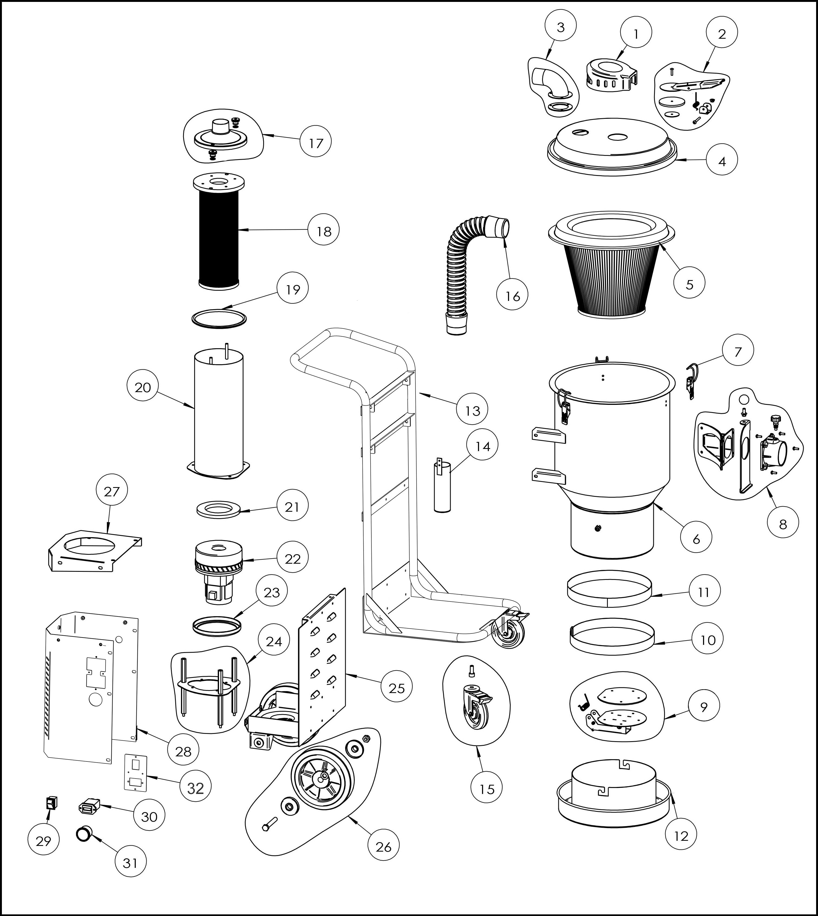

ITEM NO | QTY | PART NO | PART NAME
1 | 1 | FCKC | Clean kits cover
2 | 1 | FJPCK | Jet-pulse cleaning kits
3 | 1 | FEK | Elbow kits
4 | 1 | F18MDL | Main drum Lid
5 | 1 | F18CF | Pre-filter
6 | 1 | F18MD | Main drum
7 | 3 | FCP | Clamp
8 | 1 | FAIK | Air inlet kits
9 | 1 | FFA | Flap assembly
10 | 1 | FPS | Puller strap
11 | 1 | FASS | Anti-slip sealing
12 | 1 | FBH | Bag holder
13 | 1 | F18FMA | Frame assembly
14 | 1 | FSH | Strap holder
15 | 2 | FCW4 | 4” castor
16 | 1 | F18HK | Hose kits
17 | 1 | FHTCK | Hepa tube cover kits
18 | 1 | F00H | HEPA filter
19 | 1 | FSL-HT | Sealing for Hepa Tube
20 | 1 | FHT | Hepa Tube
21 | 1 | FMTCP | Motor Top Cushion Pad (EVA)
22 | 1 | F18M | Motor, 120V/60HZ
23 | 1 | FMCP | Motor crash pad (Rubber)
24 | 1 | FMSK | Motor supporter kits
25 | 1 | F18CS-B | Case (bottom)
26 | 2 | FW8 | 8” wheels
27 | 1 | F18CS-C | Case (cover)
28 | 1 | F18CS-S | Case (side)
29 | 1 | FSW | Switch
30 | 1 | FHM | Hour Meter
31 | 1 | FMG | Manometer/Gauge
32 | 1 | F18SP | Switch panel

EXPLODED VIEW,
Forte F26, 120V/60HZ

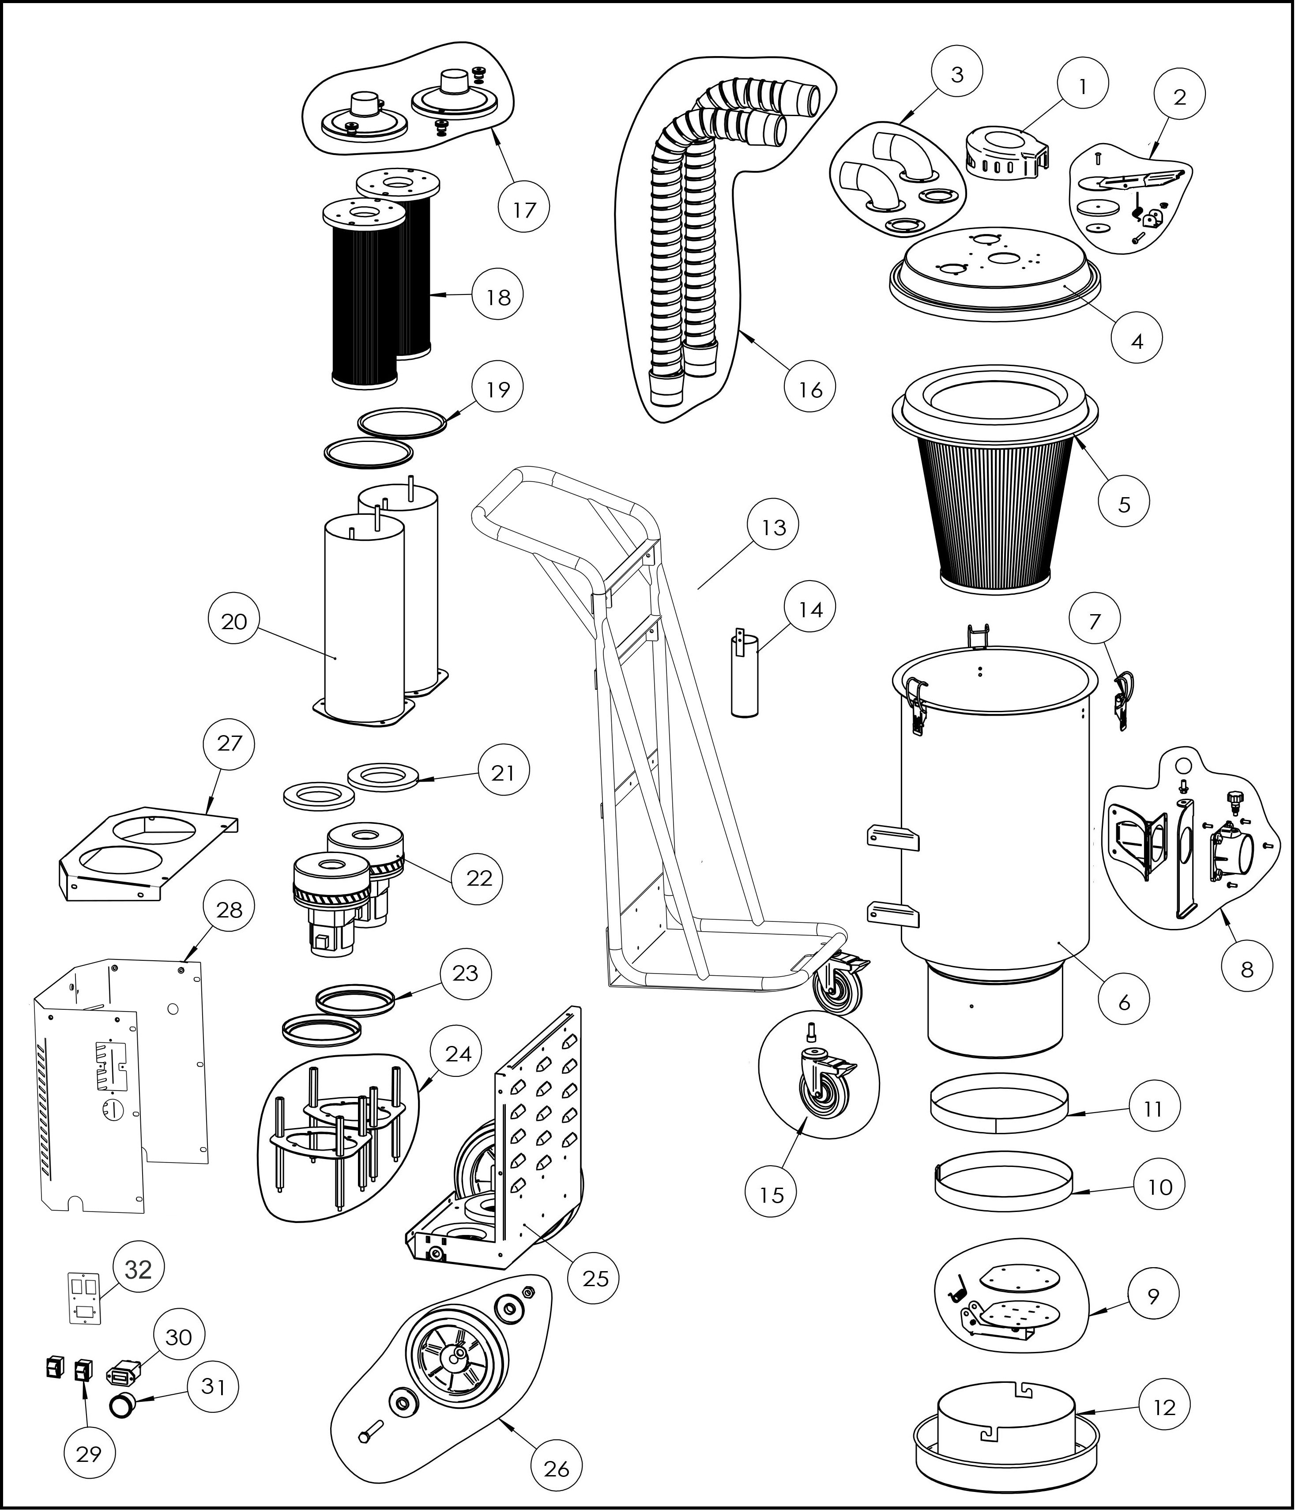

ITEM NO | QTY | PART NO | PART NAME
1 | 1 | FCKC | Clean kits cover
2 | 1 | FJPCK | Jet-pulse cleaning kits
3 | 2 | FEK | Elbow kits
4 | 1 | F26MDL | Main drum cover
5 | 1 | F26CF | Conical Pre-filter
6 | 1 | F26MD | Main drum
7 | 3 | FCP | Clamp
8 | 1 | FAIK | Air inlet kits
9 | 1 | FFA | Flap assembly
10 | 1 | FPS | Puller strap
11 | 1 | FASS | Anti-slip sealing
12 | 1 | FBH | Bag holder
13 | 1 | F26FMA | Frame assembly
14 | 1 | FSH | Strap holder
15 | 2 | FCW4 | 4” castor
16 | 2 | F26HK | Hose kits
17 | 2 | FHTCK | Hepa tube cover kits
18 | 2 | F00H | HEPA filter
19 | 2 | FSL-HT | Sealing
20 | 2 | FHT | Hepa Tube
21 | 2 | FMTCP | Motor top crash pad (EVA)
22 | 2 | F26M | Motor, 120V/60HZ
23 | 2 | FMCP | Motor crash pad (Rubber)
24 | 2 | FMSK | Motor supporter kits
25 | 1 | F26CS-B | Case (bottom)
26 | 2 | FW10 | 10” wheels
27 | 1 | F26CS-C | Case (cover)
28 | 1 | F26CS-S | Case (side)
29 | 2 | FSW | Switch
30 | 1 | FHM | Hour Meter
31 | 1 | FMG | Manometer/Gauge
32 | 1 | F26SP | Switch panel

EXPLODED VIEW,
Forte F36, 120V/60HZ

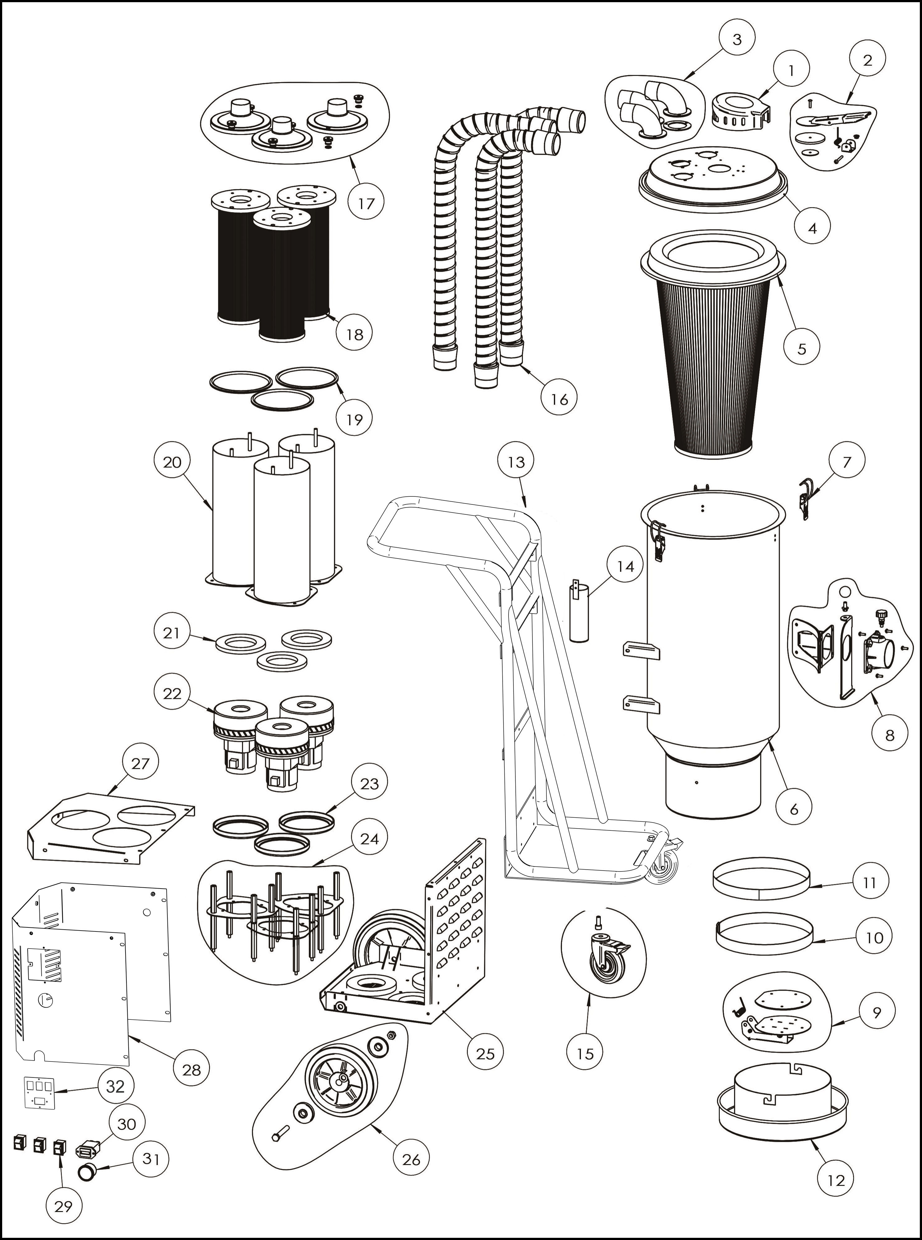

ITEM NO | QTY | PART NO | PART NAME
1 | 1 | FCKC | Clean kits cover
2 | 1 | FJPCK | Jet-pulse cleaning kits
3 | 3 | FEK | Elbow kits
4 | 1 | F36MDL | Main drum cover
5 | 1 | F36CF | Pre-filter
6 | 1 | F36MD | Main drum
7 | 3 | FCP | Clamp
8 | 1 | FAIK | Air inlet kits
9 | 1 | FFA | Flap assembly
10 | 1 | FPS | Puller strap
11 | 1 | FASS | Anti-slip sealing
12 | 1 | FBH | Bag holder
13 | 1 | F36FMA | Frame assembly
14 | 1 | FSH | Strap holder
15 | 2 | FCW4 | 4” castor
16 | 3 | F36HK | Hose kits
17 | 3 | FHTCK | Hepa tube cover kits
18 | 3 | F00H | HEPA filter
19 | 3 | FSL-HT | Sealing for Hepa tube
20 | 3 | FHT | Hepa Tube
21 | 3 | FMTCP | Motor top cushion pad (EVA)
22 | 3 | F36M | Motor, 120V/60HZ
23 | 3 | FMCP | Motor crash pad (Rubber)
24 | 3 | FMSK | Motor supporter kits
25 | 1 | F36CS-B | Case (bottom)
26 | 2 | FW10 | 10” wheels
27 | 1 | F36CS-C | Case (cover)
28 | 1 | F36CS-S | Case (side)
29 | 3 | FSW | Switch
30 | 1 | FHM | Hour Meter
31 | 1 | FMG | Manometer/Gauge
32 | 1 | F36SP | Switch panel

